Day 1: Introduction to Networking Hardware Theory

Task 1 :- Draw a labeled diagram of a typical home Wi-Fi setup showing a modem, router, switch, access point, and at least two devices (like a laptop and smartphone) connected to the network.

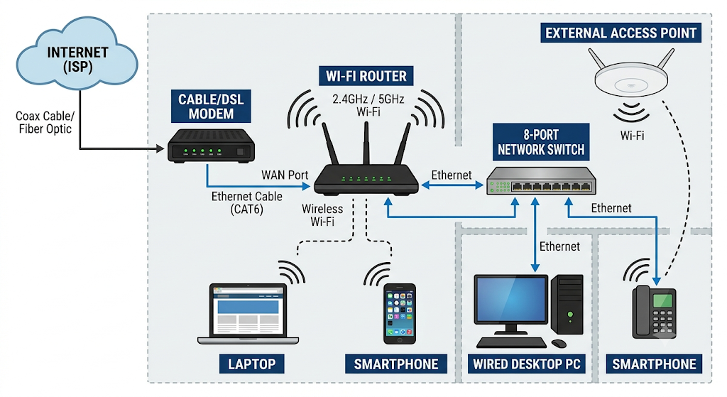

Task 2 :- List the main function of each networking hardware device: modem, router, switch, access point, and network cable. For each, give a real-life example of where you might see or use it (for example, 'router: at home to share internet').

ANS:-
Modem:
Brings internet into your house from your provider.
Example : Plugged into the wall connection near your desk.

Router:
Directs internet traffic to all your devices.
Example: At home to share internet with your family.

Switch:
Adds extra wired ports for heavy-duty connections.
Example: In a gaming setup or office to plug in multiple PCs.

Access Point:
Extends Wi-Fi signal to dead zones.
Example: Mounted on the ceiling in a hotel hallway or large office.

Network Cable (Ethernet):

Connects devices with a fast physical line.

Example: Plugged directly from your PC to the router for online gaming.

Task 3:- Take photos or find images online (with source links) of at least three types of network cables (such as Ethernet, coaxial, fiber optic) and write one line describing where each is commonly used.

Here are three common types of network cables and where they are used:

1. Ethernet Cable (Cat5e / Cat6) :-

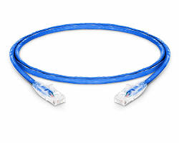

Usage: Connects computers, game consoles, and smart TVs directly to your home Wi-Fi router for fast internet.

2. Coaxial Cable :-
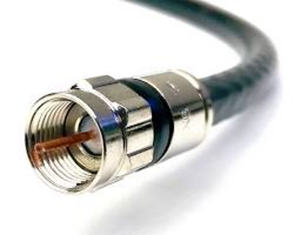

Usage :-

Plugs into cable TV set-top boxes, satellite dishes, and traditional cable modems.

3. Fiber Optic Cable :-



Usage :-
Delivers ultra-fast high-speed internet directly from internet service providers to homes and offices.

Task 4 :- Create a comparison table listing at least four differences between a router and a switch, including their main use, typical location, and how they handle data.

ANS :-

Feature | Router | Switch
Main Use | Connects different networks together (like your home network to the internet) | Connects multiple devices together within the same local network
Data Handling | Directs data between different networks using IP addresses | Directs data between specific connected devices using MAC addresses
Typical Location | At the edge of a network, connecting your home to your Internet Service Provider | Inside a local network, placed on a desk, rack, or near a cluster of wired devices
Wi-Fi Support | Usually includes built-in Wi-Fi access | Wired connections only (no built-in Wi-Fi)

